LIBRARYMANAGEMENT SYSTEM FOR GOVT .POST GRADUATE COLLEGE OF MANAGEMENT SCIENCES CHITRAL

SUBMITTED BY:
SHAHID AZAM
BASHARAT AZIZ
SAEED ANWAR
FIDA AHMAD
HASNAIN
SUPERVISED BY
MR. SHAH
GOVT .POST GRADUATE COLLEGE OF MANAGEMENT SCIENCES CHITRAL Department of Diploma in Information Technology (DIT)
Session 2018-2019

GOVT .POST GRADUATE COLLEGE OF
MANAGEMENT SCIENCES CHITRAL
LIBRARYMANAGEMENT SYSTEM FOR GOVT .POST GRADUATE COLLEGE OF MANAGEMENT SCIENCES CHITRAL

SUBMITTED BY:
SHAHID AZAM
BASHARAT AZIZ
SAEED ANWAR
FIDA AHMAD
HASNAIN
SUPERVISED BY:
MR. SHAH
A Dissertation Submitted to Board of Technical Education Peshawar Khyber Pakhtunkhwa in Partial Fulfillment of the Requirement for Award of Diploma in Information Technology.
GOVT .POST GRADUATE COLLEGE OF MANAGEMENT SCIENCES CHITRAL Department of Diploma in Information Technology (DIT)
Session 2018-2019


In The Name Of Allah, the Most Beneficent, the Most Merciful
PROJECT APPROVAL SHEET
It is certified that this project is approved and recommended as a partial fulfillment for the award of Diploma in Information Technology from Board of Technical Education Peshawar Khyber Pakhtunkhwa.

Examiner _______________________________________________

Remarks ________________________________________________

Supervisor ______________________________________________
(Mr. )

Remarks ________________________________________________

Head of Department _________________________________________

Remarks _______________________________________________________

DEDICATION


This work is dedicated to our beloved parents, father and mother for their resilience in insisting to educate us amidst the absolute poverty in which they raised us.

ACKNOWLEDGEMENT
The satisfaction that accompanies that the successful completion of any task would be incomplete without the mention of people whose ceaseless cooperation made it possible, whose constant guidance and encouragement crown all efforts with success.
We are grateful to our project guide Mr. SHAH Sir for the guidance, inspiration and constructive suggestions that helpful us in the preparation of this project.
We also thank our colleagues who have helped in successful completion of the project.

DIT Group No. 1

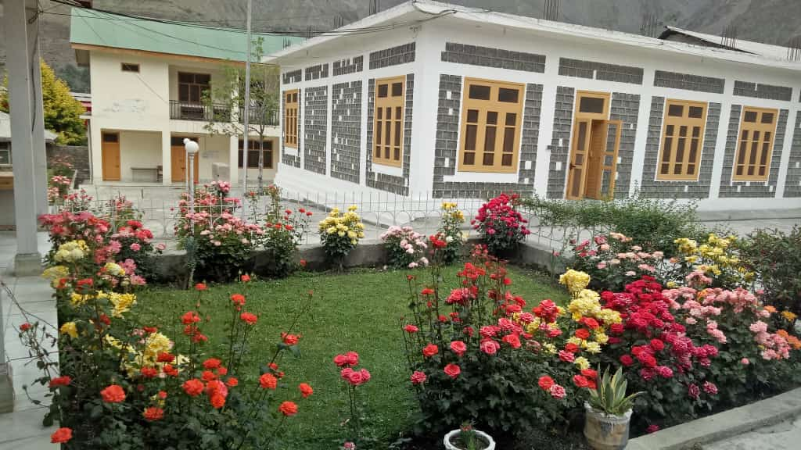

ABSTRACT

All praise be to Almighty Allah for bestowing us with the wisdom to accomplish our task.
The main the purpose of this project is to develop Library Management System for GOVT .POST GRADUATE COLLEGE OF MANAGEMENT SCIENCES CHITRAL.
Our aim was to give a comprehensive material on the fundamental concepts of Library Management System.

Project Goal: The main goals of project are as follow;
- Provide a user friendly interface.
- Manage and Access books according to authors.
- Manage and Access books according to category.
- Manage and Access library member’s information.
- Manage and Access staff member information.
- Manage and Access book issue return in files.

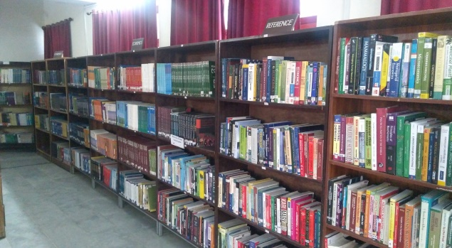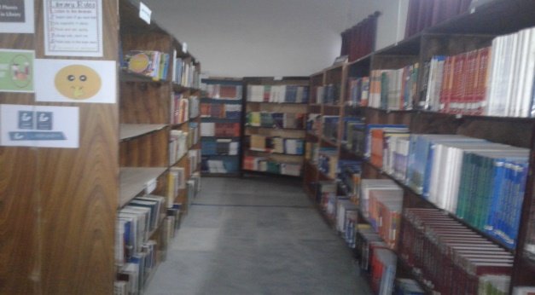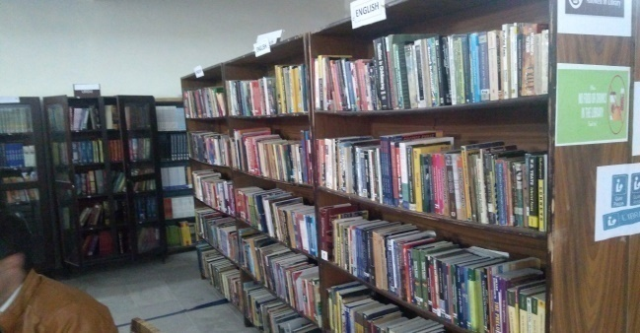

FARWARD SHEET
It is certified that, SHAHID AZAM, SAEED ANWAR, FIDA AHMAD, HASNAIN, BASHARAT AZIZ, Group No.__1__, Students of DIT 2ndSemester GOVT.POST GRADUATE COLLEGE OF MANAGEMENT SCIENCES CHITRAL have designed and developed the Library Management System (LMS). They made a lot of effort in developing this LMS (Database). We appreciate their effort and wish a bright future.

Principal
GOVT .POST GRADUATE COLLEGE OF
MANAGEMENT SCIENCES CHITRAL

Table of Contents
Approval Sheet………………………………………………………………………………….. iv
Dedication ……………………………………………………………………………………..… v
Acknowledgement …………………………………………………………………………….…vi
Abstract ………………………………………………………………………………………… vii
Forward Sheet …………………………………………………………………………………..viii
List of Abbreviations Used ……………………………………………………………….……. xv
Chapter 1 Library Management system Project …………………………………………......…...1
  - About the project……………………………...…………………………………………...…..1
  - Advantages………………...……….…………………………………………..…...…………1
  - Disadvantages……………………………………………...……………………………….... 1
  - Objectives Of library Management System………………………………...………………... 2
  - Features Of Library Management System …………………………………..………………..2
Chapter 2Database concept and Ms-Access (database)…………….……………………….…… 3

  - Data…………..……………...………..………………………………………….……………3
  - What is Database………………...……..…………………………………….…….…….……3
  - Database Properties………..…………………………………………………………………..3
  - Why We Use Electronic Database……………………...…………………………….……… 3
  - Ms-Access Database…………….……………………...…………………………….……… 4
  - Ms-Access Window……………..……………………...…………………………….……… 4
Chapter 3 Data Type in Ms Access…………………………………………………….….………5
3.1 Data type………………………………...…………………………………………………….5
3.2 Text…...……………………………………………………………………………………….5

3.3 Memo………………….……………………………...……………………………………….5
3.4 Number…………………………………………….………………………………………….5
3.5 Date and Time………………………………………………...……………………………….5
3.6 Currency……………………………………………………………………………………….5
3.7 Auto Number………………………………………………………………………………….5
3.8 Yes / No……………………………………………………………………………………….5
3.9 Hyperlink……………….…………………………………………………………….……….6
3.10 Attachment..………………………………………………………………………………….6
3.11 OLE object………..………………………………………………………………………….6
3.12 lookup Wizard….....………………………………………………………………………….6
Chapter 4 Tables in the Project……...……………………………………...………………..…....7
4.1 Design View …………………………………………………………………………….….…7
4.2 Datasheet View …….…………………………………………………………………………7
4.3 How to create table in design view……………………………………………………………8
4.4Tables in Library Management System………..……………………….…...…………………8
4.4.1Staff Personal……………………………………………………………………………8
4.4.2 Author Data.. …...………………………………………………………………………9
4.4.3 Books Catalog......………………………………………………………………………9
4.4.4 Library Member...…………………………………………………………………..…10
4.4.5 Book Collection..…………………………….………………………………..………10
4.4.6 Book Issue Table…..………………………………………………………………..…11
Chapter 5 Forms in the Project……...…………………...………………...……….…………....12
5.1Form…………….……...…………………...……………………….....…………..……..…..12
5.2 Uses of Form…........................................................................................................................12
5.3Advantages of Forms……...…………………...…...……………..…...……………..…..…..12
5 .4 Procedure for creating form in Design View……...……………..……………….……..…..13
5.5Forms in Library Management System (LMS)...…...…..…………….....………………..…..14
5.5.1Staff Form…….……...……………………...………...…………...……………..…..14
5.5.2Author Form ….……...……………………...………...…………...……………..…..14
5.5.3Book Catalog Form …….……...……………………...…………...……………..…..15
5.5.4Library Member Form …….……...……………...…...…………...……………..…..15
5.5.5 Book Collection Form …….……...…………...……...…………...……………..…..16
5.5.6 Book Issue Form …….……...……………...………...…………...……………..…..16
5.5.7 Option Windows …….……...……………...………...…………...…………….…...16
Chapter 6 Data base Terminologies and ERD ……...…………………..........…….…………....17
6.1 Entity……………………………………..……...…………………..........…….…………....17
6 .2 Entity Types …………………………….……...…………………..........…….…………....17
6.3 Attributes………………………………………...…………………..........…….…………....17
6.4 Relationship……………………………...……...…………………..........…….…………....18
6.4.1 Create Relationship……...………………….................................…….…...………....18
6.4.2 Relationship in Library Management System (LMS)…….................……...………....18
6.4.3 Entities For the proposed System…………...………………………………………...19
6.5 ER Model……………………………………......…………………..........…….…………....19
6.5.1 Symbol Used in ERD ……………………………........………………….…………....19
6.5.2 Relationship Types ………………………………..........……………..….…………....19
6.5.3 Modality………………………...…………........................…..........…….…………....20
6.6 Advantages of ER Model……………………….…………………..........…….…………....20
6.7 ERD for the Proposed System………………………….……………………………………21
Chapter7 Queries in the project. …………………...………….........…….…………….….…....22
7.1 Query ……………………………...…...…………………..........……………...…………....22
7.2 Uses of Query ………………………...…………………..........…….…………..….……....22
7.3 Advantages of Query ………...……………...…………….………..........…….…………....22
7 .4 Procedure for Creating Query ……………………………...………........…….…………....23
7 .5 Procedure for executing saved query……………………………...…......…….…………....23
7 .6 Query in Library Management System (LMS)…………….……...…......…….…………....24
7.6.1 Author wise Book………….……………………………...…......…….…………....24
7.6.2 Category wise Book…….…….…………………………...…......…….…………....24
7.6.3 Book Issued By Author………….……………………..…...........…….…………....25
7.6.4 Member Issue Book………….……….…………………...…......…….…………....25
7.6.5 Book Issued by Staff………….…………………………...…......…….…………....26
7.6.6 Book Issue by desired Author………….…..……………...…......…….…………....26
7.6.7 Book Issue after 30th June………….………...……….…...…......…….…………....27
7.6.8 Book Issue between desired period ………….………………......…….…………....27
Chapter 8 Reports in the Project…………..………….………………......…….…………..…....28
8.1 Reports……………......………………………………….…………………………..………28
8.2 Creating a Reports………..…………………………………………………………..………28
8.3 Creating a Report Using Wizard……………………………………………………..………29
8.4Creating a Report Using Design View ……………………..………………………..………29
8.5 Auto Format in Report……………… ……………………..………………………..………30
8.6 The advantages of Using MS Access Report ……………………..………..………..………31
8.6.1 Ease of Use ……………………..……………………….……………………..………31
8.6.2 Data Presentation……………………..………………….……………………..………31
8.6.3 Updating Reports ……………………..………………....……………………..………31
8.7 Uses of Reports in MS Access……………… ……………………..………………..………31
8.8 Reports in Library Management System (LMS) ……………… ……………………...……32
8.8.1 Author Wise Book……………………………...………… ……………………...……32
8.8.2 Category Wise Book……….…………………...………… ……………………...……32
8.8.3 Book Issued by Author………………………...………… ……………………....……33
8.8.4 Book Issued to Members…………….………...………… ……………………....……33
8.8.5 Book Issued by desired Author…………………………... ……………………....……34
8.8.6 Book Issued between desired period…………………………... …………….......……34
8.8.7 Books Issued by Staff……….…………………………... ……………………....….…34

Chapter 9 Switchboard in the Project………..…..………….……...…………......………..…....35
9.1 Switchboard…………………….…………………………......……………………....….…35
9.2 Key Benefits of Creating a Switchboard in MS Access ……………………………....….…36
9.3 Create a switchboard in MS Access …………………….…………………….……....….…36
9.4 Add items to a switchboard in MS Access ………….………….…………………......….…37
9.5 Edit items in a switchboard in MS Access ……………………….…………………....….…37
9.6 Delete a Switchboard or Switchboard items in MS Access ……………………...…....….…38
9.7 Display the Main Switchboard on Start Up in MS Access ……….......…………….....….…38
References………..……………………………...……………………………………………….39

List of Abbreviations Used
LMS --------------------------------------------------------------------------Library Management System
ERD------------------------------------------------------------------------------------Entity Relationship Diagram
E-R-------------------------------------------------------------------------------------Entity Relationship
MS Access------------------------------------------------------------------------------Microsoft Access
VBA------------------------------------------------------------------------------------Visual Basic for Application
DAO--------------------------------------------------------------------------- Data Access Objects

